COSC 3380

Name: ___Nicholas Moore___________ PS ID# _1390458__
Project 3:
(100 points.)
(Due date found in the COSC 3380 Detailed Syllabus!)

1. a. Create stored procedure ProductLineSale _______ 20 points
1. b. Run ProductLineSale ______ 5 points
1. c. Display PRODUCT 5 points

2. a. Create trigger StandardPriceUpdate 20 points
2. b. Run trigger StandardPriceUpdate _ 10 points

3. JSP Web Page SalestoDate.jsp ___ 40 points

PLEASE ENTER YOUR GRADE IN THIS BOX & ALSO on the CHECK SHEET:

Use the COSC3380 Database created in Project 2.

Part 1. (30 points) Stored Procedures

1. (30 points)
a. (20 points) Create a simple procedure ProductLineSale, to be used by that will set a sale price to the existing Product table in the COSC3380 Database by adding a new column, SalePrice DECIMAL (6,2), that will hold the sale price for the products:

.

The ProductLineSale procedure should scan all rows of the Product table. Products with a ProductStandardPrice of $400 or higher are discounted 10 percent, and products with a ProductStandardPrice of less than $ 400 are discounted 15 percent. As with other database objects, there are Oracle SQL commands to create, alter, replace, drop, and show the code for procedures.

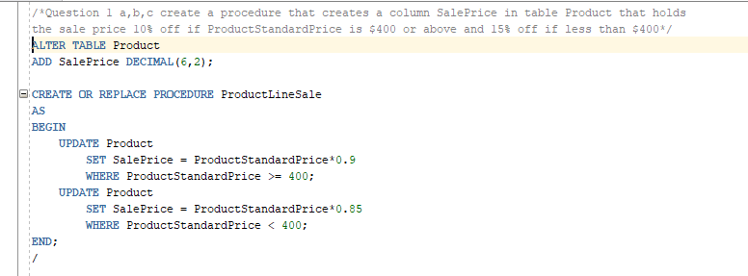
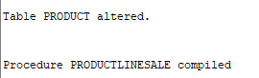

b. (5 points) Run the ProductLineSale procedure in Oracle.

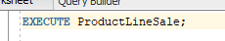
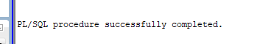

c. (5 points) Display the contents of the PRODUCT table.

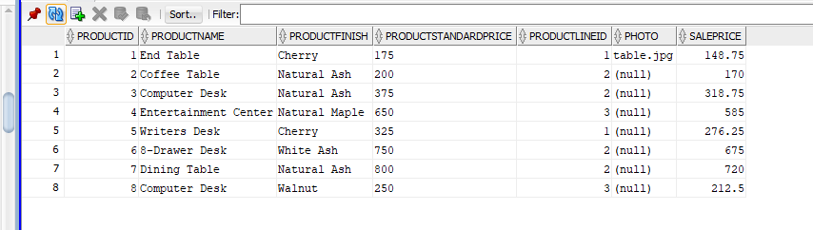
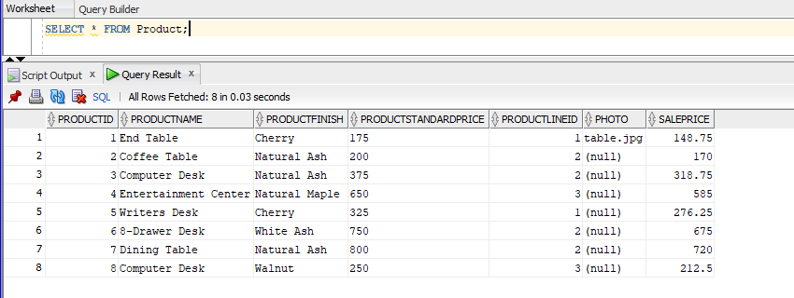
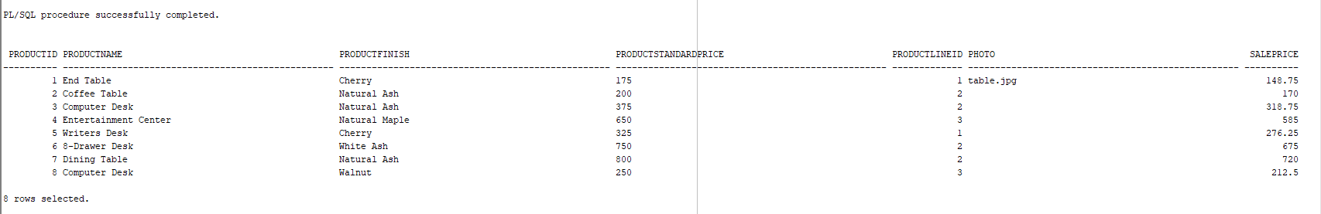
Part 2. TRIGGERS (30 points)
- (20 points) Write and
- (10 points) Run the trigger named StandardPriceUpdate

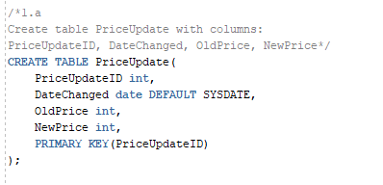
Changed table to have default sysdate for DateChanged

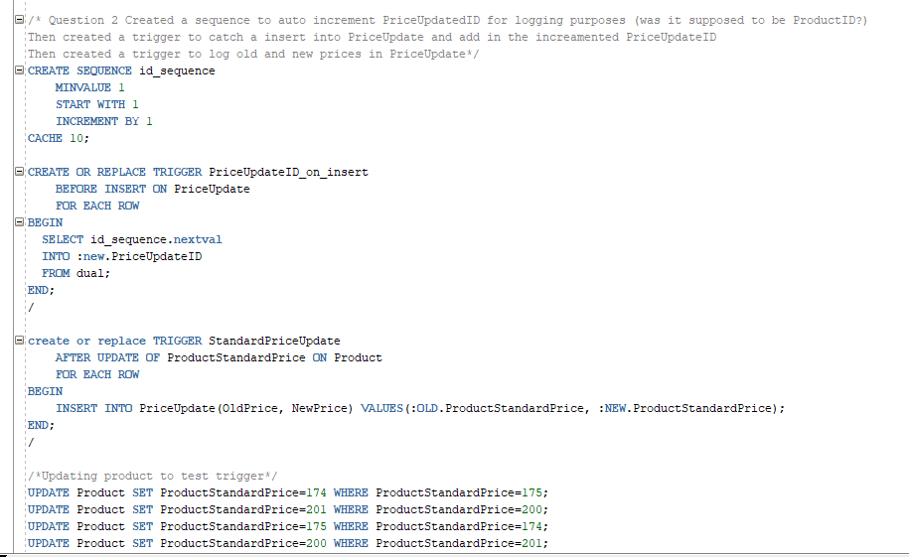
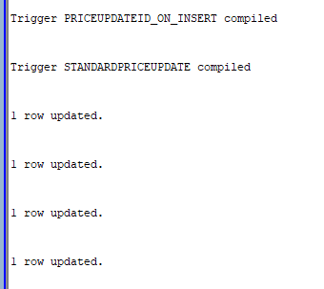
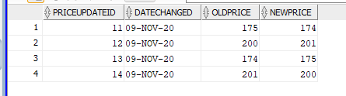
Part 3. (40 points) Accessing COSC3380 Database from JSP
(PHP (Optional)
ASP (Optional))

A JSP Web Page (40 points)
Create SalestoDate.jsp

(jsp page oracle 12c DBMS backend)
(1.index.jsp;
2. NetBeans Project with source; project and output;
3. web page screenshot)
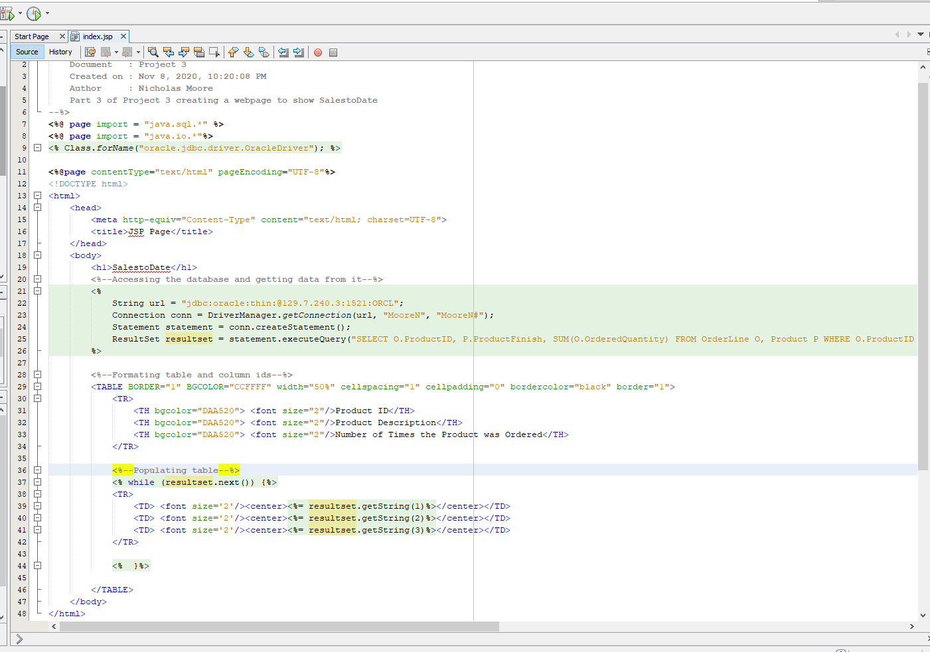

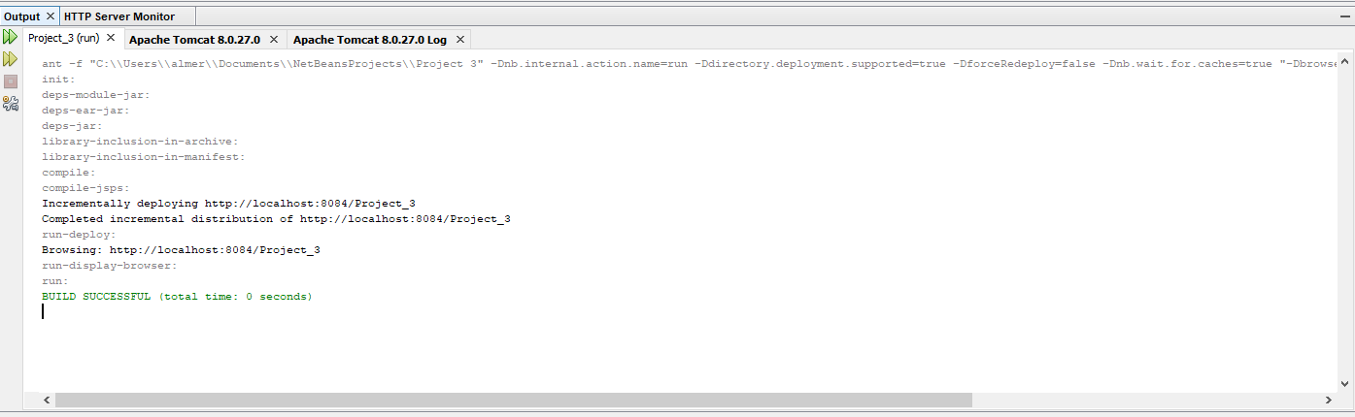
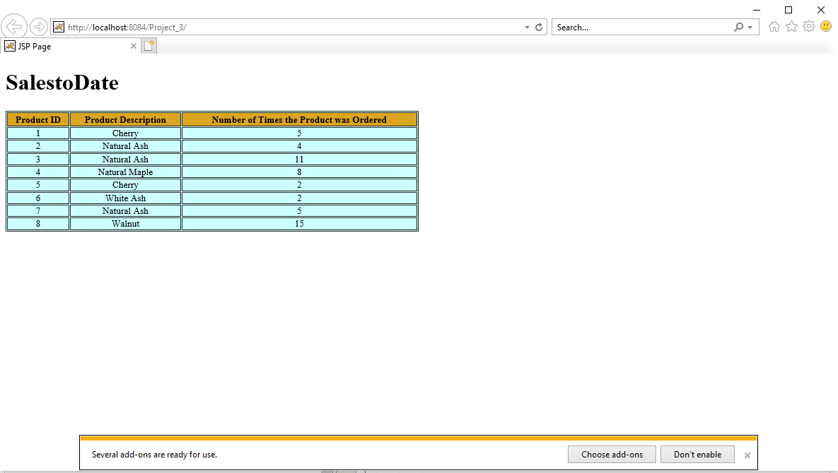
(Optional) A PHP Web Page
Java, C, C++, C#, and Perl are APIs that can be used with MySQL. PHP is one of the most popular APIs for several reasons. Support for MySQL has been built into PHP since PHP4. It has a reputation for ease of use, short development time, and high performance. PHP5, recently released, is more object oriented than PHP4 and includes several class libraries. It is considered to be relatively easy to learn. Intermediate- level programmers will learn it quickly.
Create SalestoDate.php

(php page mysql DBMS backend; Please create and turn in Project3mysql.sql)

(Optional) An ASP.NET Web Page
Create SalestoDate.aspx

(asp page oracle 12c DBMS backend)
You need to turn in hard copy and electronic:
. The .sql scripts with comments, Project3.sql.
. The .zip of the 3 Projects (2 NetBeans; 1 Visual Studio). (only to BB)

. The screenshots of Stored Procedures, Trigger, NetBeans 6.9.1 & Visual Studio 2010 Projects, Web Pages AND the source CODE, Project3.doc. (BOTH to BB and HARDCOPY)

Without Project3.doc you will get ZERO!

You are to download your ZIPPED ASP.NET Project / NetBeans Project/ PHP Project into BB then to your local computer in 232 PGH in the first 10 minutes of the class.
PLEASE DO NOT RAR!

